Chris Weeden

csc 415

10/6/18

I have chosen option 1 for assignment 3. I will be addressing an issue on GrowStuff where when someone searches for a crop name it will only give a result if it is the crops original name. This will be an extension of their website made in ruby using the ruby on rails framework just to stay consistent with their codebase. This modification should allow for someone to use the normal name for a crop or any of the alternate names that are stored alongside it with the possibility of giving a best fit should the name have been spelt incorrectly. This project could be very useful for users of Growstuff to eliminate the need to know the main name or possibly the correct spelling if the name they typed in is close enough to what they wanted. I will need to implement a single linkage agglomerative clustering algorithm for the approximation portion and for exact matches since the data for the alternative names is not alphabetized it will need to use a linear search since sorting and using binary search would take nlog(n)+log(n) time to do the same thing as a linear search’s n time. The single linkage agglomerative clustering algorithm works best with arrays since arrays are much faster than other data types for this algorithm a hash table may also be used but is ultimately unnecessary I will also use a doubly linked list for O(n) insertions and O(1) deletions as I remove the lowest value while maintaining an orders list. I expect this to force me into good practices for documentation since someone outside of this school will need to read and understand what I put down, I will also need to find a good workflow for this since it’s pretty hands off when it comes to when things need to be done. The open source license is the GNU Affero General Public License v3.0 since that is what grow stuff already uses.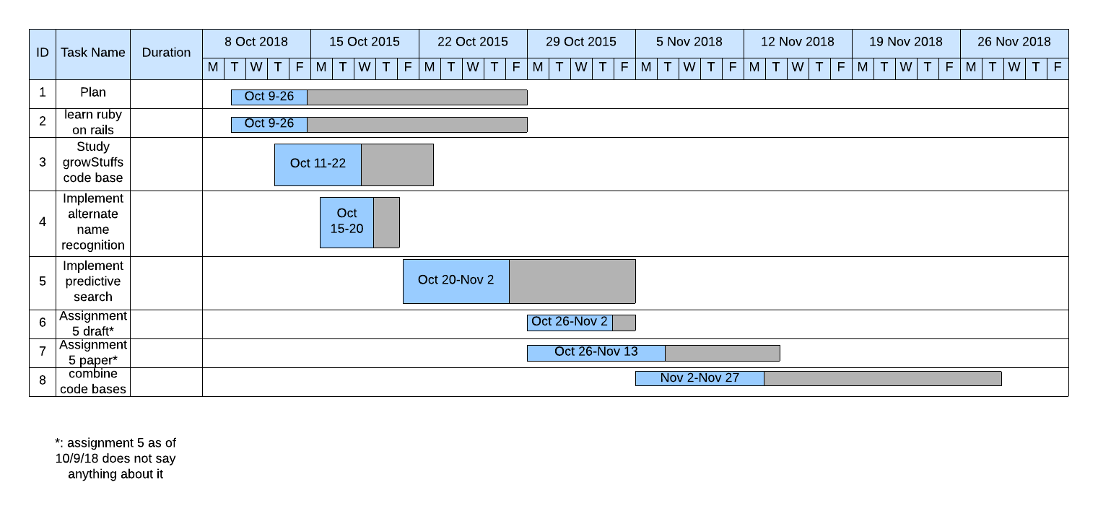

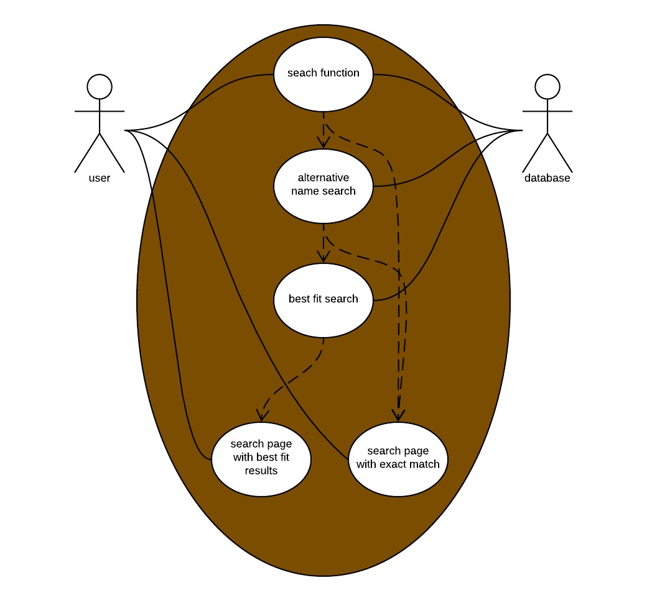

There was no dropbox to place the prototype in so you can find it on the github repository GrowStuffEnhancedSearch or on my vm student1 account in the subfolder assignment3